**CIS-350  
Infrastructure Technologies**

**Lab 1 Report**

**Student Name:** ___**Louis Ries_________**Insert the *Lab1_Tree* file from p. 24 of the Lab1 instructions into the space provided or use the *Alt-PrtScr* keys to capture the full screen output (full window) from command *TYPE Lab1_Tree* on p. 24 and paste that window here.

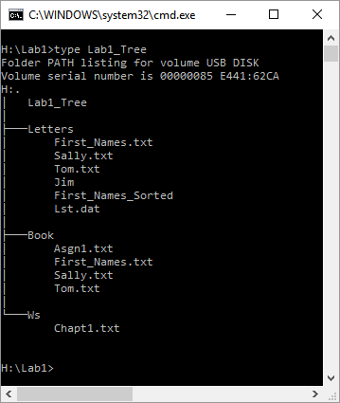

1. You have the following directory structure. ROOT (replaced by "\"), LETTERS, BOOK, BUSINESS, PERSONAL, CLUB, ROTARY, and JCC are names of directories/subdirectories, whereas MEMBER.1, MEMBER.2, and MEMBER.3 are names of files. Assume that the root directory ("\") stores the following files: *Go.bat*, *Paper1*, *Paper2*, *Paper3*, *Sheet1a*, *Sheet2*, *Sheet3*, *Sheet4*, *Shell1*, and *Shell2*. The system prompt displays"C:**\**>" which means that the current drive is C and the current directory is the root directory "**\**".



In the diagram above the word ROOT represents the root directory, i.e., "**\**". In all commands below, use the backslash "**\**" to represent the root directory. Do not to use the word ROOT. The root directory "**\**" is just the origin for other directories/subdirectories. All questions (a) through (j) are based on the above diagram.

1. Write a command to copy file *Go.bat* to directory *PERSONAL*. The copied file should have the same name as the original file.

copy \Paper1 \Letters\Personal\

1. Write a command to copy a file *Go.bat* to directory *BUSINESS*. The copied file should have new name *Go_copy.bat*.

copy \Go.Bat \Letters\Business\Go_copy.bat

1. Write a single command to copy all files starting with *She* to directory *BOOK*.

Copy \She* \Book\

1. Write a single command to erase from the root directory all files that have digit *1* in their name.

Del \*1*

1. How many files would be erased by the command from p. (d) above? _3_____________
2. Assume that *Paper3* is a large file. What command would you use to display the contents of the file one screen at a time (to prevent the output from scrolling off the screen)?  
   TYPE \Paper3 | MORE
3. Write two separate *SORT* commands. Both commands would accept input from file *Paper1*. However, the first command would route the output to file *Paper10*, and the second one would append the output to file *Paper10*.   
   SORT \Paper1 > Paper10  
   SORT \Paper1 >> Paper10
4. Look at the diagram. Assume that prompt "C:\LETTERS\CLUB>" is displayed. Write the command which would change the current directory to JCC.   
   CD JCC
5. Look at the diagram. Assume that prompt "C:\LETTERS\CLUB>" is displayed. In the space provided, sketch the directory structure with files which would command *TREE* /F generate.

C:.

├───JCC

└───ROTARY

├───MEMBER.1

├───MEMBER.2

└───MEMBER.3

1. Describe what a command *DIR | SORT /R > Dirlis* does.

DIR outputs the names of all the folders and files in the current directory, and then “pipes” them into the command SORT with the /R argument. Sort by default sorts lines in ascending order, but the /R argument means it should sort in descending order(reverse). The “>” means the output should be written to the file as named on the right side of the symbol. A single “>” means to write a new file.

1. Optional. Briefly describe any issues with the commands which did not work. Point me to the specific pages and suggest changes. Thanks.